**Steps to run a Program:**

**Step1:**

First Install Python 3 in your Computer and tick on pip command

**Step2:**

After python is installed the next step is to open CMD

**Step3:**

After opening CMD install all the libraries which are defined in the program using Pip command

**pip install streamlit**

**pip install pandas**

**pip install sklearn**

**pip install matplotlib**

**pip install plotly**

**pip install seaborn**

**pip install keras**

**Step4:**

After installing all the libraries , open cmd in same directory where all your datasets and program is available and run the command

**streamlit run app.py**

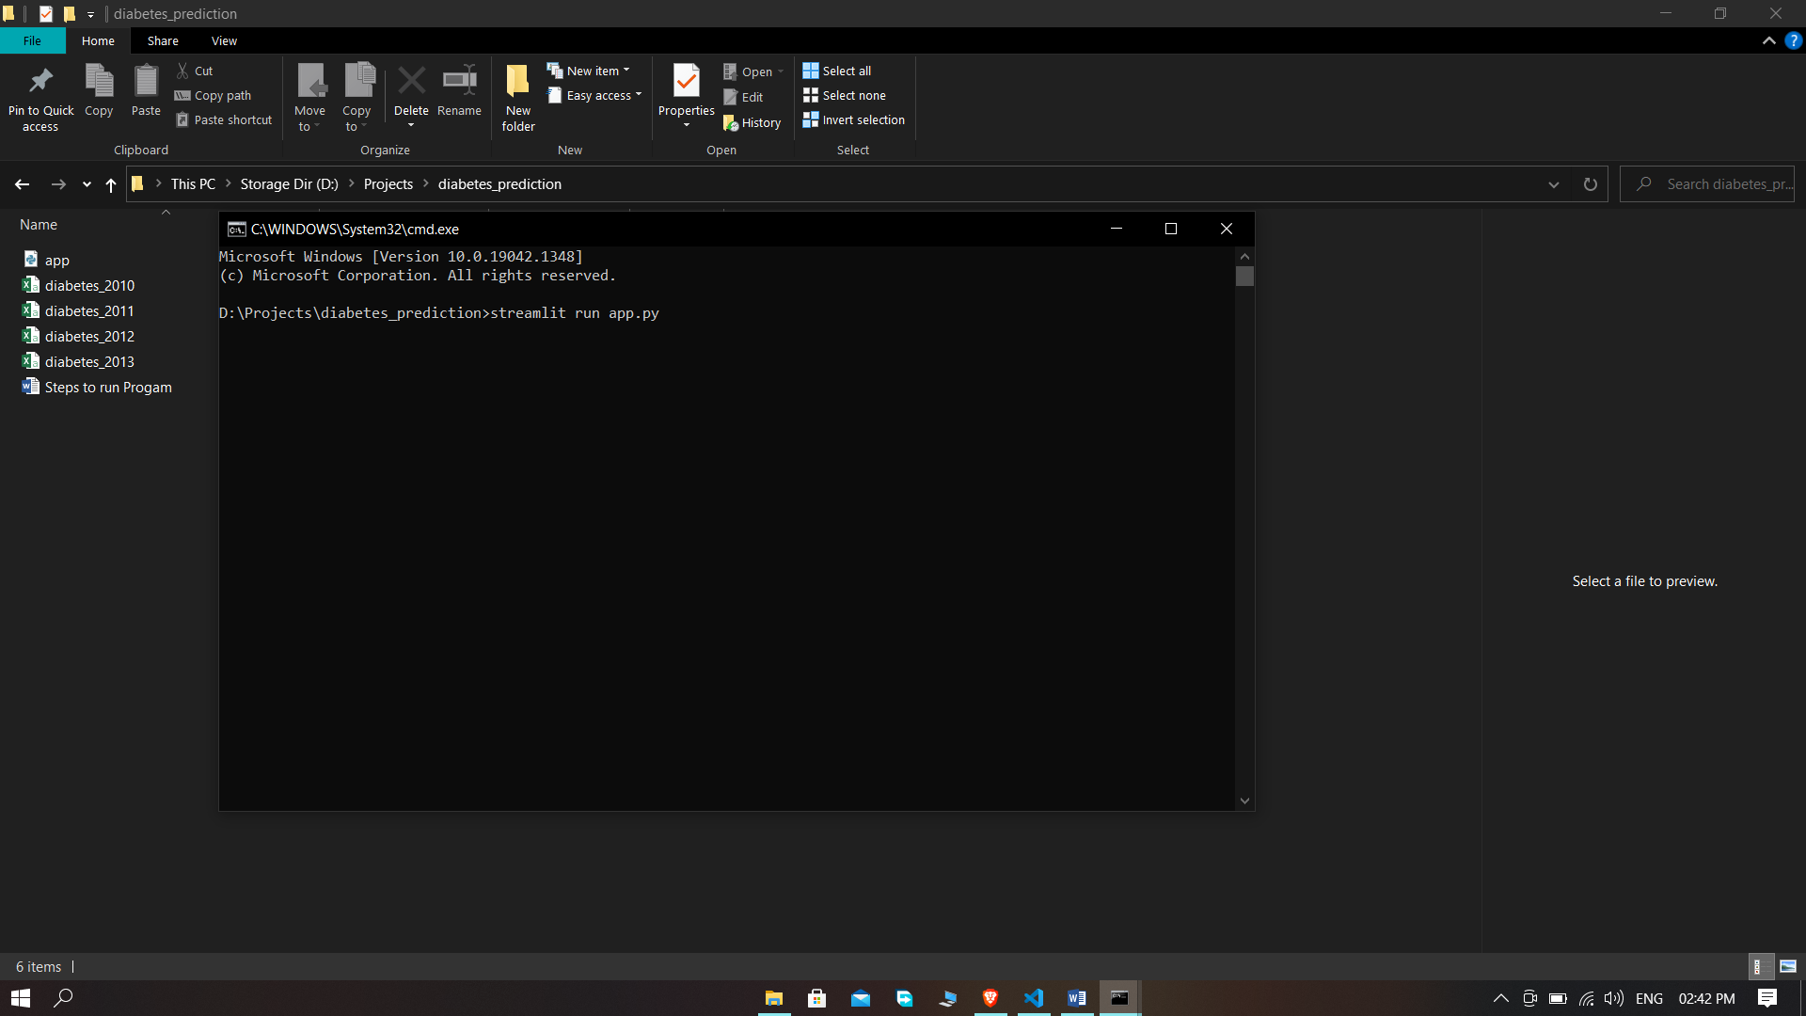

**Step 5:**

It will ask you for a mail if open it first time so enter it.

And After that will open a local host into your browser

And then you can adjust the slider to know that your diabetic or not.

